**Appendix C: Assignment Submission Cover Sheet**

**Student Id: BIDA23-087**

**Student names: Tibawo Timuhwe**

**Student email: Bida23-087@thuto.bac.ac.bw**

**Cohort:**

**Assignment title: WMD assignment 2024**

**Date of submission: 17/05/2024**

**Programme of**

**Study: BIDA**

**Year of Study: 1**

**YEAR 1**

**Intellectual property statement By checking the box below, I certify**

**that this assignment is my work and is free from plagiarism. I**

**understand that the assignment may be checked for plagiarism**

**by electronic or other means and may be transferred and stored**

**in a database for data-matching purposes to help detect**

**plagiarism. The assignment was not submitted for assessment in**

**any other unit or institution. I have read and understood the**

**Botswana Accountancy College plagiarism guidelines policy.**

**☐ Agree**

**Signature…………………………………….**

**Date……………17/05/2024……………………………..**

**WMD ASSIGNMENT**

1. A) Website specifications (Objective, Purpose, and Goals)

* The objective of the website can be multiple things, including promoting upcoming movies, providing information about current releases, and offering behind-the-scenes content.
* The purpose of the website is to serve as a central hub for all things related to Warner Bros. entertainment properties, enhancing brand visibility, and fan engagement.
* Goals may include increasing ticket sales for movies, generating hype and anticipation for upcoming releases, and building a strong online community of fans.

b) The target for our website based on age are people between the age of 10 and 50 which is basically catering for all age groups both younger and older, with the younger being the newer fans of the franchise and the older being people who grew up on the types of movies or tv shows that shown by us.

The website should target male and female viewers but mostly towards the male as we provide more on the superhero movie front and our games as well meaning mostly males will be accessing our services.

The technical aptitude of our website caters to the gaming community as we offer games on our platform so they may visit it to access the games.

c)The type of content to be designed is purely on the entertainment front as that is basically what Warner Bros is all about. This will be sort of a central unit where you can access any type of entertainment you want because it will offer Movies, Games, Tv shows and even certain apps.

2)Information Design & Taxonomy

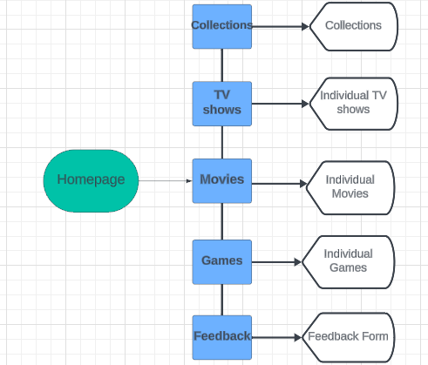

Story Board Flowchart or site map

This storyboard flowchart shows us how easy it is for a user to be able to surf through our website and move from page to page in as little as 1 or 2 clicks. This is very important for the structure of the website because if users find it difficult to navigate through your website then they may end up leaving it as it is and not using it.

3)Page Template Design

Home page

The above diagram is a wireframe of our index.html page which is our home page as shown we have our logo on the top left corner of the page next to our navigation bar which is to the right of our logo which are both interactive. We then have our movies tab which is were we showed previews of movies which are produced by warner bros. Followed by our TV shows which just shows the tv show posters and the same with our games. Our collections and feedback pages can be accessed by clicking on them in the navigation bar. And lastly we have our page footer which has the copyright information and social media links for warner bros

Movies

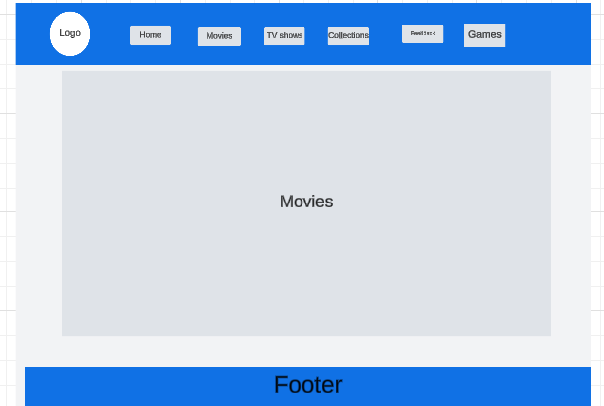

This represents our movies page which is where we find information on movies produced by warner bros.

TV shows

This Wireframe represents The TV shows section of our webpage where we have all our popular tv shows.

This section shows the games page of our webpage.

This section shows the collections page of the web page.

4.Technical brief

For our website to work at full functionality we used different applications for different purposes. All these software tools played a role in the publication and maintenance. We used GitHub to publish our website, write down the html and CSS as well as the JavaScript of the website.

Another tool that was used was a website named fotor.com which was used to remove unnecessary background colours or materials from our photos which were used as logos and photos of our posters on the website. This tool helped to improve the visual appeal of the website as it maintained the colour scheme through pictures and logos.

We used HTML5 to structure the content of our webpage in order for it to have uniformity and meaning as well as the use of CSS3 in order to style the website for it to be visually appealing and also for the website to be responsive.

5. Quality Assurance

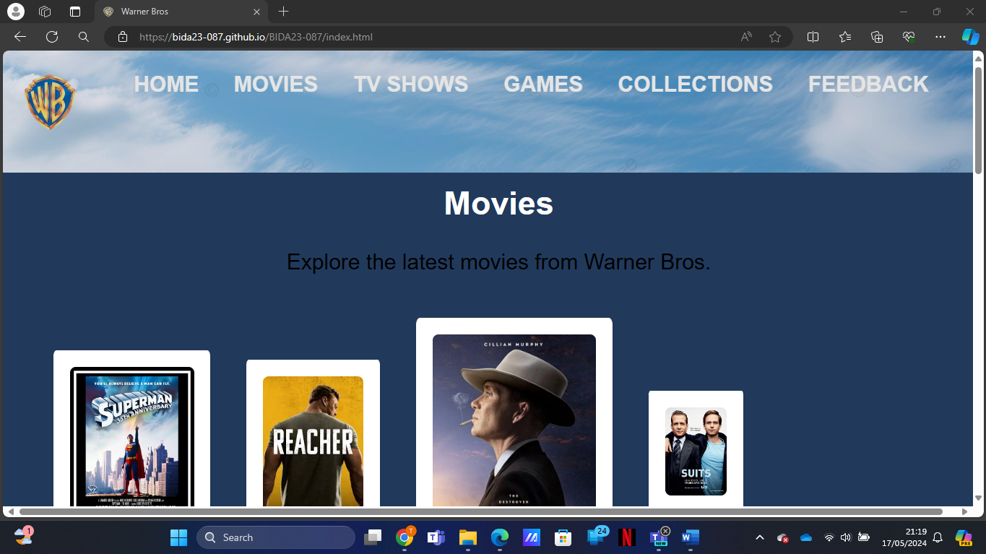

This is a screenshot of our website shown in Microsoft edge showing all features and also navigation bar still active with hover effects and CSS still being responsive.

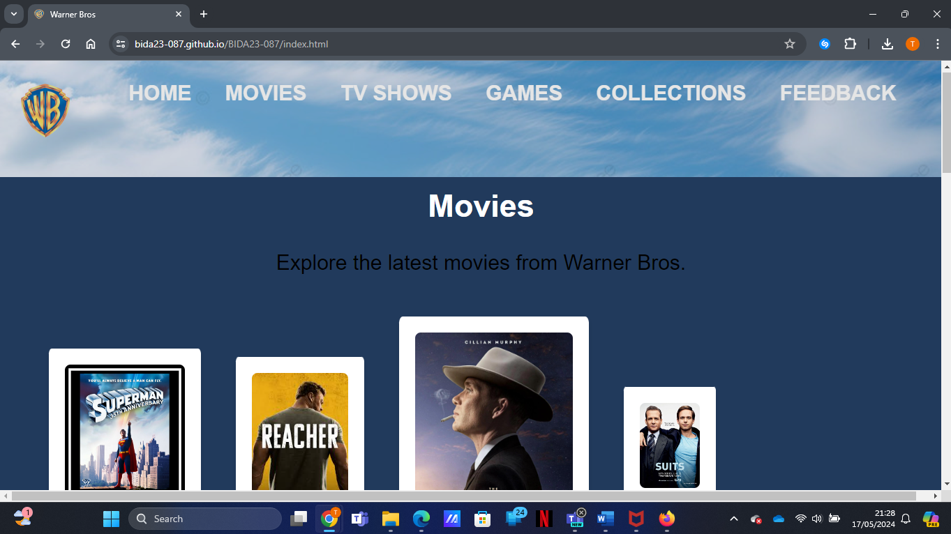

This screenshot shows the website in google chrome.

6.Publishing & Promotion

<https://bida23-087.github.io/BIDA23-087/index.html>

I created repositories in GitHub to store website files. This is where we have our HTML and photos. I used an internal style sheet that is the reason I do not have a CSS file.

7.Future Developments.

In the future I hope to utilize the use of external CSS because I realized I kept spending a long time editing the stylesheet in each file which caused a few mistakes and also it would be faster in general because I wont have to keep constantly having to edit every file when I want to modify the stylesheet.

Another development I hope to achieve in the future is better structuring of my webpage to have more uniformity as it is a bit messed up in the posters which is not visually appealing.

8.Report Organization